|  |  |
| --- | --- |
| visionlogo | logo |

College of Computer and Information Sciences

**Research project proposal**

**Master of Science in Computing (Data Analytics)**

**Title**

**Zero-shot Learning for unsupervised Aspect-based Opinion Mining**

|  |  |
| --- | --- |
| Student Name | Manar Ali AlGhunaim |
| Student ID | 441006266 |
| Submission Date | December 10, 2020 |

First semester 2020-2021

**Contents**

Aim 3

Problem Statement & Motivations 3

Background 5

Scope 5

OBJECTIVES 5

Methodology 6

Timeline 7

Risk Management 7

Source and Use of Knowledge 7

Ethical, Legal, Social, Security and Professional Concern 7

Conclusion 8

References 8

**Zero-shot Learning for unsupervised Aspect-based Opinion Mining**

# Aim

The overarching goal of this research project is to build an automated system that mines aspect-based customer opinions from online reviews to help customers choose the best product or service according to their fine-grained needs, as well as enabling businesses to better assess and improve their offerings.

# Problem Statement & Motivations

Sentiment Analysis is the task of detecting users' opinion about a product or service.

This could be done using either:

* Rule-based methods, leveraging a lexicon, such as the NRC.
* Machine Learning methods, specifically classification.

For each of them the unit of analysis could be the document or the aspect.

Most studies in sentiment analysis focus on document-level analysis, in which the goal is to predict the underlying overall sentiment for a given document (e.g. customer review).

Although such an approach is useful of course, it doesn’t convey a full picture as to what customers think about a product or service.

For example, a visitor to a restaurant might like the food, but not so much the service. Or he might like them both but feels the price is too expensive, and so on.

Clearly such a fine-grained assessment of a product or service is much more informative to both customers and businesses.

As for customers, It helps them zone-in on the specific aspects about a product or service pertinent to their needs and desires.

E.g. A student living abroad might not care much about the nice ambience of a restaurant nor the diligence of the service as much as he cares about affordable prices and adequate food quality.

On the other hand, a young couple on a weekend will most probably care much more about ambience, cleanliness, service as well as food quality, because they want the experience to be enjoyable and memorable. While they wouldn’t care much about pricing, for they don’t eat in the restaurant on a daily basis.

As for businesses, It also helps them improve their offerings by providing accurate information as to what exactly their customers like and dislike about their products and services.

To perform aspect-level sentiment classification the traditional method involves the following:

1. Manual segmentation of each customer review into sentences.
2. Manual labeling (annotation) for each sentence to indicate its aspect as well as its underlying sentiment.
3. Training a multi-label supervised ML model on the labeled data.
4. Using the trained model to predict the sentiment and aspect of a new review.

Of course, this approach is time-consuming and expensive, due to the manual work involved in the first two steps.

Worse, if the business is providing different lines of products, it needs to do all this laborious work for each set of reviews pertaining to each line of product.

To this effect, our research question will address: **How to extract aspect-based customer opinion in an unsupervised way?** Hence, eliminating steps 1,2 and vastly reduce the time, effort and cost needed to achieve the same results.

# Background

As described in the previous section, sentiment analysis is concerned with automated detection of customer opinion about a product or service.

In the literature, our research question falls under a category of sentiment analysis called: aspect-based opinion mining, or aspect-based sentiment analysis.

Most previous studies in sentiment analysis use either rule-based methods or supervised learning methods for document-level analysis, and almost exclusively supervised methods for aspect-level analysis, where customer reviews are hand-segmented, then hand-labeled for its underlying aspect and sentiment.

As mentioned, this is very time-consuming and expensive.

**Note:** Full literature review will be conducted and written in the final documentation of this research project.

# Scope

**Scope**

The scope of this project will be focusing on the food industry, specifically restaurants.

**Limitations**

An important limitation of this study pertains to sentences containing two different polarities assigned to two different aspects.

e.g. “The food is excellent but the manager was awful”.

Our proposed method will be able to detect both aspects (food and service), but wouldn’t be able to assign the correct polarity for each aspect.

This is due to the fact that, as will be flushed out in the *Methodology* section, this research employs a pretrained dependency parser to segment customer reviews into sentences.

if the dependency parser deemed the aforementioned example *one-sentence,* the limitation *takes place*, as the sentiment classifier is trained to assign one polarity for each piece of text.

if the dependency parser deemed the aforementioned example *two-sentences,* the limitation *doesn’t take place*, as the sentiment classifier will assign a polarity for each of the two sentences.

But since customers usually segment their different opinions about different aspects in different sentences, it is assumed that this limitation will not significantly affect prediction accuracy.

**Note:**

Considerable effort will be put into addressing this limitation as well, and if it couldn’t be done within the allotted time-frame, it will be listed as an important future work.

# OBJECTIVES

**The main goal** is to solve the research question stated in the *Motivation* section. Precisely, **to build a system that extracts aspect-based customer opinion without the need for hand-labeling or hand-segmentation of customer reviews.**

**To Measure our success:** we’ll use a previously hand-labeled data set for test purposes only. This data set will not be used for any training.

**The Goal:** is to achieve 80%+ accuracy on the unsupervised aspect extraction task, and 95%+ on the binary sentiment detection task.

The desired accuracy for the unsupervised task is benchmarked much less than the supervised one due to the well known fact that supervised learners in general perform much better than their unsupervised counterparts, for they were specifically trained on annotated data to perform a specific task.

**Time-frame:** Completing this research project will take approximately five months, starting from January 2021 until May 2021.

# Methodology

The proposed approach that achieves the fine-grained assessment of aspect-level analysis is as follows:

1. Train a supervised Deep Learning model to predict document-level sentiment (labels are already available from the customer star-ratings, so there’s no time-consuming hand-labeling involved here).
2. Use a pretrained dependency parser to segment reviews into sentences.
3. For each sentence extract its aspect and its sentiment using:
   1. A zero-shot classifier (for aspect extraction)
   2. The trained DL model in step 1(for sentiment detection)
4. Aggregate all sentences related to a user-input restaurant name to produce a detailed report as to the percentage of positive and negative sentences distributed over each aspect. Something similar (but not limited) to the following graph: 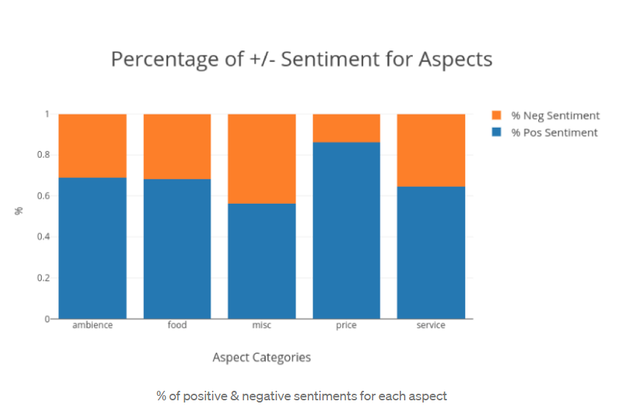

[Source: Aspect-Based Opinion Mining](https://medium.com/@pmin91/aspect-based-opinion-mining-nlp-with-python-a53eb4752800)

**Notes on the implementation**

* Document level analysis will be performed using the state-of-the-art Transformer architecture models, such as BERT, ALBERT, XLNet.

There will be some other baseline models as well such as logistic regression and fast-text.

* Zero-shot Learning for aspect extraction will be implemented using the BART Model, pretrained on the [Multi-genre NLI (MNLI) corpus](https://cims.nyu.edu/~sbowman/multinli/).

# Timeline

By using Gantt charts for all task categories to follow the schedule during four months.

# Risk Management

To mitigate any risk factors that might impede the successful completion of this project within the allotted time-frame, e.g. sickness, technical difficulties .. etc, the plan will be to complete the research project one month before the due date, and leave this month as a contingency measure.

# Source and Use of Knowledge

The latest [version of Yelp Academic Dataset](https://www.yelp.com/dataset) will be used as the main dataset for the research.

For testing the performance of the zero-shot classifier, we need another data set that has been hand-labeled on the aspect level. We chose the [SemEval-2014](https://alt.qcri.org/semeval2014/task4/index.php?id=data-and-tools) data set for this purpose.

# Ethical, Legal, Social, Security and Professional Concern

It’s an open source dataset from Yelp Academic Dataset, so there are no recognized ethical issues at hand.

# Conclusion

Building an Aspect-based sentiment analysis system in a timely, cost-effective workflow is the essence of this research project.

The document at hand proposed the main idea behind the system, a quick literature review, scope, limitations, objectives as well as the envisioned methodology.

The aim is to provide a bird’s-eye view of the research project that serves as a road map for its successful completion.

# References

* [Zero-Shot Learning in Modern NLP](https://joeddav.github.io/blog/2020/05/29/ZSL.html)
* [Benchmarking Zero-shot Text Classification: Datasets, Evaluation and Entailment Approach](https://www.aclweb.org/anthology/D19-1404/)
* [Aspect-based Opinion Mining](https://medium.com/@pmin91/aspect-based-opinion-mining-nlp-with-python-a53eb4752800)
* [Zero-Shot Learning with Semantic Output Code](https://www.cs.cmu.edu/~fmri/papers/zero-shot-learning.pdf)

# Appendix (A) On Zero-shot Learning

In NLP, zero-shot learning means to have a model do something that it wasn't explicitly trained to do. This could be done by reformulating a classification problem into a ***Natural Language Inference*** one.

Natural language inference is the task of comparing two sentences: a "premise" and a "hypothesis", with the purpose of determining whether the hypothesis is true (entailment), false (contradiction), or unrelated (neutral), given the premise.

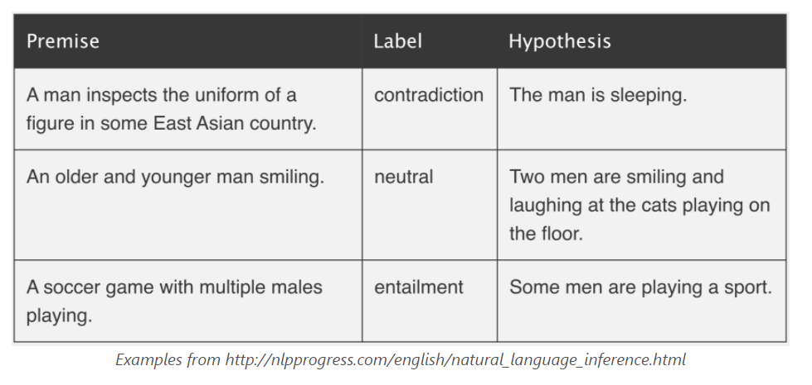

When using transformer architectures like BERT, NLI datasets are typically modeled via sequence-pair classification. To elaborate, both the premise and the hypothesis are passed through the model together as distinct sentences, then a classification layer is added that learns to predict one of 3 classes: contradiction, neutral, entailment.

To adopt this methodology in aspect-based opinion mining, we can take the sequence we're interested in labeling as the "premise" and to turn each candidate aspect into a "hypothesis." If the NLI model predicts that the premise “entails” the hypothesis, we take the aspect to be true.

For example, if we have this sentence:

*“The pizza was really great!”*

This will be considered the premise. And we’ll have 4 candidate aspects “hypotheses” that this sentence may entail:

*food, service, ambience, price*

the algorithm will use a template for each of the 4 hypotheses, so it becomes:

*“This text is about {food}”*

*“This text is about {service}”*

*“This text is about {ambience}”*

*“This text is about {price}”*

Now we ask the classifier to predict, for each of the 4 hypotheses, whether the premise entails it or not? if it does, then the aspect is true.

Obviously more than one aspect could be true as well. As in:

*“The pizza was really great, but the manager was awful!”*

In this example the zero-shot classifier is likely to assign high probability to both food and service, and we take both of them to be true.

# Appendix (B) Software Used in the Project

The following tools and software packages will be utilized:

* Main Programming Language: [Python](https://www.python.org/)
* Data Analysis and Cleaning: [Pandas](https://pandas.pydata.org/)
* Text Preprocessing: [spaCy](https://spacy.io/) and [NLTK](https://www.nltk.org/)
* Data Visualization: [Plotly](https://plotly.com/python/)
* Shallow ML, model selection and evaluation: [Scikit-learn](https://scikit-learn.org/)
* Model Interpretation: [LIME](https://github.com/marcotcr/lime), [SHAP](https://github.com/slundberg/shap)
* Deep Learning and Zero-shot Learning: Either ([tensorflow](https://www.tensorflow.org/) with [Ktrain](https://github.com/amaiya/ktrain)) or ([Pytorch](https://pytorch.org/) with [Fastai](https://docs.fast.ai/) and [Transformers](https://github.com/huggingface/transformers))